Principles of Microeconomics
In-Depth Assignment 3
Chapters 11,12, & 14

Name Date

- _____ The price of a factor of production that is in fixed supply is called

  - economic profit.
  - opportunity cost.
  - a compensating differential.
  - economic rent.

- _____ Marginal productivity theory implies that in a perfectly competitive market economy, a worker will receive income

  - That is greater than the value of her marginal contribution to the production process.
  - equal to the value of her marginal contribution to the production process.
  - That is less than the value of her marginal contribution to the production process.
  - That is greater than, less than, or equal to the value of her marginal contribution to the production process depending on her ability to negotiate with employers.

- _____ A firm chooses its profit-maximizing quantity of capital by

  - Examining the total cost of capital equipment
  - Comparing the marginal revenue product of capital with the rental price of capital.
  - Determining the rate at which the firm can borrow funds to purchase plant and equipment.
  - Comparing the price of capital with the price of labor.

- _____ An example of a resource price difference that causes reallocation is

  - A higher wage for a job requiring more education and training
  - A higher wage for working at a dangerous job
  - A higher wage for working at a job at night
  - A higher wage for one of two jobs that are equally attractive

- _____ An organization of employees that has the legal right to bargain with employers about wages and working conditions is called a

  - Monopsony
  - Closed shop
  - Guild
  - Labor union
Table 1

Number of machines | Output of Pins (boxes per week) | Marginal Product of Capital | Poduct Price ($ per box) | Total Revenue | Marginal Revenue Product of Capital | Rental Cost per Machine | Added profit from renting one more machine
0 | 0 | -- | $100 | $ 0 | --- | $550 | ---
1 | 12 | 12 | 100 | 1,200 | $1,200 | 550 | $ 650
2 | 21 |  | 100 |  | 900 | 550
3 | 28 | 7 | 100 |  | 700 | 550 | 150
4 | 34 | 6 | 100 |  |  | 550
5 | 39 |  | 100 | 3,900 |  | 550
6 | 43 | 4 | 100 |  | 400 | 550 | -150

Table 1 reflects the situation at Adam’s pin factory. He can rent machines for $550 each.

- Refer to table 1. Fill in the blanks in the table.

- Refer to table 1. What is the profit-maximizing number of machines to rent?

- Refer to table 1. Explain why this number of machines is profit-maximizing.

- _____ In general, the labor supply curve

  - Is perfectly elastic at the equilibrium wage rate.
  - Slopes downward because firms will hire fewer workers at higher wages.
  - Is vertical at the equilibrium wage rate.
  - Slopes upward because as the wage rises the opportunity cost of leisure increases.

Article 1
In 2008, 57 million people started new jobs in the United States despite the recession. A majority of these people left their previous jobs and found new jobs in the same industry. The amount of job turnover in the United States is huge, and the data for new hires and separations (employees who quit, retire, or are fired) provide valuable information about the labor market. "The labor market is like any other market, driven by supply and demand," said John Wohlford, branch chief of the Job Openings and Labor Turnover Survey at the Bureau of Labor Statistics. "But for a long time, we only measured the supply, in unemployment. The job openings survey, started in 2000, allows us to measure demand." In many industries, new hires and separations decline at the same time because current employees may become hesitant about leaving jobs if they think it will be more difficult to find a new job. In cases where the number of separations grows even as new hiring declines, employers have been forced to eliminate jobs.
Source: Hannah Fairfield, "Labor Lost, and Found," New York Times, June 6, 2009.

- _____ Refer to Article 1. All else equal, if job turnover has people leaving jobs and finding new jobs in the same industry, this will

  - Increase the demand for labor and the supply of labor.
  - Increase the demand for labor and decrease the supply of labor.
  - Not change demand or supply in the labor market.
  - Decrease the supply of labor, but not change the demand for labor.
- _____ Refer to Article 1. If the number of people leaving jobs grows while new hiring declines, this indicates that the
  - Labor supply curve is shifting to the right.
  - Labor demand curve is shifting to the right.
  - Labor demand curve is shifting to the left.
  - Labor supply curve and labor demand curve are both shifting to the right.
- _____ The wage rate is the opportunity cost of

  - Working overtime
  - Working
  - Leisure
  - Consumption

Figure 1

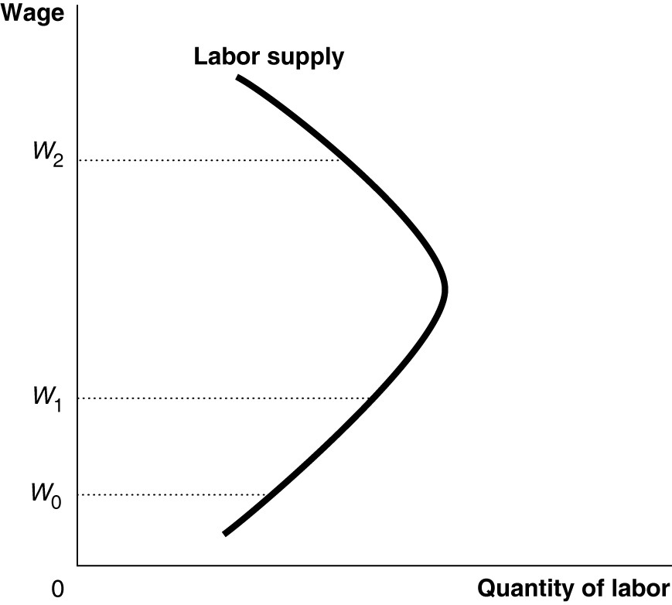

- _____ Refer to Figure 1. Which of the following is true if the wage rate increases from W0 to W1?

  - The income effect is larger than the substitution effect.
  - The supply curve is unit-elastic.
  - The substitution effect is larger than the income effect.
  - income effect and the substitution effect are equal.

- _____ Refer to Figure 1. Which of the following is true at W2?

  - The substitution effect is larger than the income effect.
  - The income effect is larger than the substitution effect
  - The supply curve is positively sloped.
  - The income effect and the substitution effect are equal.
Article 2

A growing order book for new construction has lifted the shipyard’s employment from a low of about 2,400 at the beginning of the year to “3,000 and change” now, said Kevin Graney, Nassco’s vice president and general manager.
Nassco plans to hire about 500 more employees and have 3,500 by the time it’s done, Graney said.
Employment at Nassco has been on the decline since it peaked at 4,700 employees in 2008, datab from the San Diego Business Journal’s Book of Lists shows. Those were the days when the yard was in the middle of an order of 14 U.S. Navy supply ships and producing five double-hulled tankers for U.S. Shipping Partners LP.
Today, commercial projects outnumber Navy projects at the Barrio Logan shipyard.
Nassco kicked off another major effort earlier this month when Mayor Kevin Faulconer cut the first steel plate for an order of five commercial tanker ships. The ships are being built for American Petroleum Tankers, part of Kinder Morgan Energy Partners LP (NYSE: KMP). Each will measure 610 feet in length and weigh 50,000 tons.
Nassco is building three almost identical tankers for Seabulk Tankers Inc.
In addition, a novel container ship for TOTE Inc. is 60 percent complete and on schedule, while a second ship for the same customer is “well underway,” Graney said. The 764-foot-long ships will be the world’s first container ships to run on liquefied natural gas.
Military construction continues at Nassco with the third Mobile Landing Platform ship. Nassco is in negotiations with the Pentagon for a fourth ship, Graney said, and a fifth ship may be added to an upcoming defense budget.

From: SAN DIEGO BUSINESS JOURNAL September 22, 2014, page 6. www.sdbj.com

- Refer to article 2. Explain the relationship between the hiring practices and job orders at Nassco. What kind of demand does this explain (for labor)?

Article 3

In an interview with Jacob Goldstein NPR, on Planet Money http://www.npr.org , Jacob talked about what insurance covered and what it didn’t:

What are some of the other sort of big things that are not covered?

GOLDSTEIN: Bedbugs, despite what you might have hear on local news, are not like an earthquake or flood. They’re relatively isolated and not that expensive to deal with, compared to some giant disaster. Insurance won’t pay for bedbugs or for that matter any kind of bugs for a different reason. They don’t want to give you an excuse to do ridiculous things. If I had bedbug insurance, I’d furnish my entire apartment from stuff I found on the street. What’s the worst thing that could happen? I have bedbug insurance.

- Refer to article 3. What problem with asymmetrical information is Goldstein referring to?

Scenario 1

A student has started and blog finds that the blog is becoming more popular. It is bringing in $100,000 per year from advertisers now, and he feels it will eventually surpass what he will make after graduation in a job matching his major. He’s already spent $100,000 on school.

- Assuming the student makes a rational decision, should he choose to remain in school, or should he quit school and blog full time? What behavior, in behavioral economics, describes the possible irrational choice he could make?

- _____ Because of asymmetric information, most used cars that are offered for sale will be sold for prices that are greater than their true value. Because of this fact, the used car market falls victim to

  - Deadweight loss and economic inefficiency.
  - A surplus of used cars.
  - Adverse selection
  - The free rider problem.

Table 2

Company | Bid
M | $40
N | 30
O | 20
P | 15
Q | 10

- _____ Table 2 above lists the bids (in millions) made by 5 companies for tracts of land in Louisiana. The winning bidder was granted the right to drill for oil found on the land. All bids were based on the firms' best estimates of the value of the oil they expected to find. A winner's curse will result from this auction if

  - The average bid of all five companies is greater than the winning bid.
  - The winning bid is greater than the value of the oil found on the land.
  - The winning bid is less than the value of the oil found on the land.
  - The value of the oil found on the land is more than $30 million but less than $40 million.

- Explain whether the winner's curse would apply to an auction where everyone had perfect information about the value of the item being auctioned.

- _____ What is the term that describes a situation in which one party to an economic transaction has less information than the other party?

  - Asymmetric information
  - Unequal market structure
  - Inefficient market hypothesis
  - Monopsony

- _____ Which of the following is an example of adverse selection?

  - Someone with automobile insurance drives more recklessly than someone without insurance.
  - People prefer to buy new cars rather than used cars.
  - Someone who did not install fire alarms and a sprinkler system in a building he owns buys insurance for the building.
  - The odds of a fire rise after a building is insured because the person with fire insurance is likely to pay less attention to fire hazards.

- _____ The situation in which one party to a transaction takes advantage of knowing more than the other party to the transaction is called

  - Moral hazard
  - Adverse selection
  - Asymmetric information
  - Adverse hazard

- _____ Two consequences of asymmetric information are adverse selection and moral hazard. An important distinction between the two is

  - adverse selection exists prior to the completion of a transaction while moral hazard occurs after the transaction is completed.
  - moral hazard exists prior to and after the completion of a transaction while adverse selection occurs only after the transaction is completed.
  - moral hazard refers to the likelihood that a transaction will lead to the harm of the other party.
  - moral hazard is the motive that is behind one party entering into a transaction with another party.

25) Define neuroeconomics.

